**Modeling improved e-flows for the Middle Fork American River Project**

Kristen Podolak

For the paper: Can forest restoration “move the needle” on reservoir management objectives?

Revised 5.11.2017

**Introduction**

Forest restoration plan – American Rivers and The Nature Conservancy partnered in 2015 to purchase 10,000 acres of private timberland upstream of French Meadows Reservoir. They are working with the U.S. Forest Service who manages the interspersed parcels to restore the forests using forest thinning and prescribed and managed wildfire, so that large wildfires do not burn at high intensities across this watershed.

*Need a description from Ed of planned forest treatments* (total acres in watershed, treatment acres, types of treatment, timing, philosophy)

This study will model forest restoration –> hydrology change + (reservoir hydropower impact + e-flow impact)

**FERC relicensing and e-flows**

Placer County Water Agency applied for a new 50-year license on February 24, 2011 for continued operation and maintenance of the Middle Fork Project (FERC Project No. 2079) through February 28, 2063. The application is currently in review with the U.S. Forest Service and the Federal Energy and Regulatory Commission (FERC). The instream flow requirements have a minor effect on Project operations. The benefits of the instream flow requirements are, “power generation, consumptive water supply, system capability and reliability, public services, and resource stewardship.” (PCWA BA/BE, p. 4-38).

Resource stewardship in the proposed license focuses on improving flows for threatened aquatic species: Foothill yellow legged-frogs, Western pond turtles, and Hardheads. We focused on environmental flows (e-flows) for Foothill yellow legged frogs (FYLF) as the two other sensitive instream species are found downstream of the Oxbow Powerhouse and are affected by the powerhouse peaking reach and the Sacramento Municipal Utility Districts operations on the South Fork Rubicon River, making consideration of these two species beyond the scope of this study.

In the proposed license terms, three instream flow requirements have been outlined for the bypass reaches downstream of French Meadows Reservoir and Hell Hole Reservoir to improve conditions for Foothill yellow legged frogs (FYLF). These include minimum instream flows, spring pulse flows, and ramping rates for spill flows to make the impaired hydrographs closer to the natural unimpaired hydrograph, before the project. The minimum instream flows maintain water during the low flow period in the end of the summer and fall, but levels are slightly higher than unimpaired flows (need to make a figure). Spring pulse flows apply only to Above Normal and Wet years. Spring pulse flows move sediment, facilitate willow and cottonwood regeneration in the riparian corridor, and provide streamflow indicators for breeding FYLF. Ramping rates for spill flows to generate hydropower decreases the likelihood of stranding FYLF eggs and individuals (). The downramping rates on both spill and pulse flows also impact channel geomorphology, as the water levels drop, sediment falls out of suspension or stops moving along the streambed. The gradual decrease allows for sorting of sediment and creation of heterogenous habitat patches (need to add citations here from FERC studies and modeling of sediment mobility at different flows).

The implementation of the instream flow requirements under the new license go into effect when the infrastructure (outlet works) is completed. This ranges from within 30 days of the license issuance through six years after the issuance for the pulse flows and down ramp of spill flows from Rubicon River below Hell Hole Reservoir. For the purposes of this study, given that forest fuels reduction efforts will likely not be entirely completed in the next six years, it seems safe to assume all the new license infrastructure upgrades will be completed and all instream flow requirements can be implemented when any additional water would be supplied.

**Foothill yellow legged frog**

The foothill yellow legged frog (FYLF, *Rana boylii*) is listed as a ‘species of special concern’ by the California Department of Fish and Wildlife and a ‘sensitive species’ by the U.S. Forest Service. The species is near extirpation in the Sierra Nevada, having disappeared from more than half of its historical localities in the Sierra Nevada (Lind 2005). Water infrastructure, especially large dams, that alter natural hydrographs are the primary cause of the decline in regulated rivers (Hayes et al. 2016).

FYLFs breed in the spring when the water temperature increases and streamflow decreases. They lay their eggs on the lee side of boulders and cobbles instream between May and early June in the Sierra Nevada. This timing is risky because discharge events can disrupt breeding, scour eggs and tadpoles, or strand tadpoles, especially dam releases (Lind et al. 1996), but allows enough time for tadpoles to metamorphose and become juveniles before overwintering.

FYLF abundance is highest downstream of Hell Hole Reservoir in the Rubicon River, and egg masses have been detected (Figure x). Habitat downstream of French Meadows Reservoir on the Middle Fork American River is described by frog biologists as limited, why, and there are no egg masses detected until close to the confluence with the Rubicon River. Abundance was low in the Middle Fork American River bypass reach upstream of Ralston Afterbay, and individuals were observed rarely in the Middle Fork American River peaking reach.

**Methods**

**Site characteristics**

Area, elevation, land cover, streamflow and precipitation.

Native aquatic species are adapted to the ‘natural flow regime’, the flow signature throughout of

year in the Mediterranean climate of the Sierra Nevada. Flows are high and variable from April through early June during snowmelt, and low in the summer when temperatures are hot and dry. There is high inter-annual variability with mean annual precipitation ranging from 89 to 239 centimeters.

Reservoirs and hydropower operations, focused on Middle Fork American Project (FERC #). *Leave this section for Jon.*

“The Project consists of two major storage reservoirs, two medium

regulating reservoirs, three small diversion pools, and five powerhouses that began

operation in 1967. The Project’s major storage reservoirs, French Meadows and Hell

Hole, have a combined capacity of 342,583 acre-feet (ac-ft). The Project has a total

dependable generation capacity of 223.7 megawatts (MW) and has an average annual

energy production of 1,039,078 megawatt-hours (MWh).” P. 1-1 (01_BA-BE file folder, Draft Biological Assessment/Biological Evaluation)

Bypass reaches are sections of the river below reservoirs or diversions where operations result in the diversion of a portion of the water from that reach. These include the Middle Fork American River below French Meadows Reservoir and Rubicon River below Hell Hole Reservoir. In these reaches, flows are reduced and more stable during the winter/spring and equal to or greater than unimpaired conditions in the summer/fall to meet minimum instream flow requirements. The peaking reach refers to only one reach, the river below Oxbow Powerhouse, where flows fluctuate substantially to meet power demand or to support whitewater recreation. Summer/fall flows in the peaking reach are higher and more variable than unimpaired conditions.

**E-flow impacts**

There are opportunities within the proposed license terms to improve pulse flows and spill ramping rates to be better aligned with current science, and what other hydropower projects in the Sierra Nevada are currently implementing. Since the development of the proposed license terms, Yarnell et al. (2015) observed the need for spring recession flows to decrease gradually, with flow steps no more than 20% decrease between two days. Currently, the proposed license terms have down ramping rates that range from 1-40% for different flow steps for both reservoirs. A faster downr amp is allowed at French Meadows Reservoir because there are no FYLF present downstream until the Middle Fork Interbay. However, this argument precludes improved habitat downstream of French Meadows Reservoir where FYLF could exist in the future with improved e-flows.

The US Forest Service asked for ±10% of the pulse flows “to reduce the possibility of stranding aquatic biota if PCWA were to release substantially more flow than the minimum standard and then rapidly scale back the flow, resulting in possible stranding.” (EIS p. 97)

**Pulse flows** – In Above Normal and Wet years increase the peak by 10%, and extend the recession limb by one day for each time step, plus adjust the ramping rate between time steps so that it does not exceed a 20% decrease in flow. This applies to both Hell Hole and French Meadows Reservoirs. The total increase in the duration of the pulse flows is 4 days for each reservoir, matching the proposed license terms. The increase in water for this scenario compared to the table of flows in the FERC license is 1,463 cfs and 1,025 cfs for French Meadows and Hell Hole during wet years and 1,223 and 705 cfs in an above normal year.

**Increase in flow (cfs) in improved pulse flows**

|  |  |  |
| --- | --- | --- |
| Reservoir | Wet year | Above Normal year |
| French Meadows | 1,463 | 1,223 |
| Hell Hole | 1,025 | 705 |

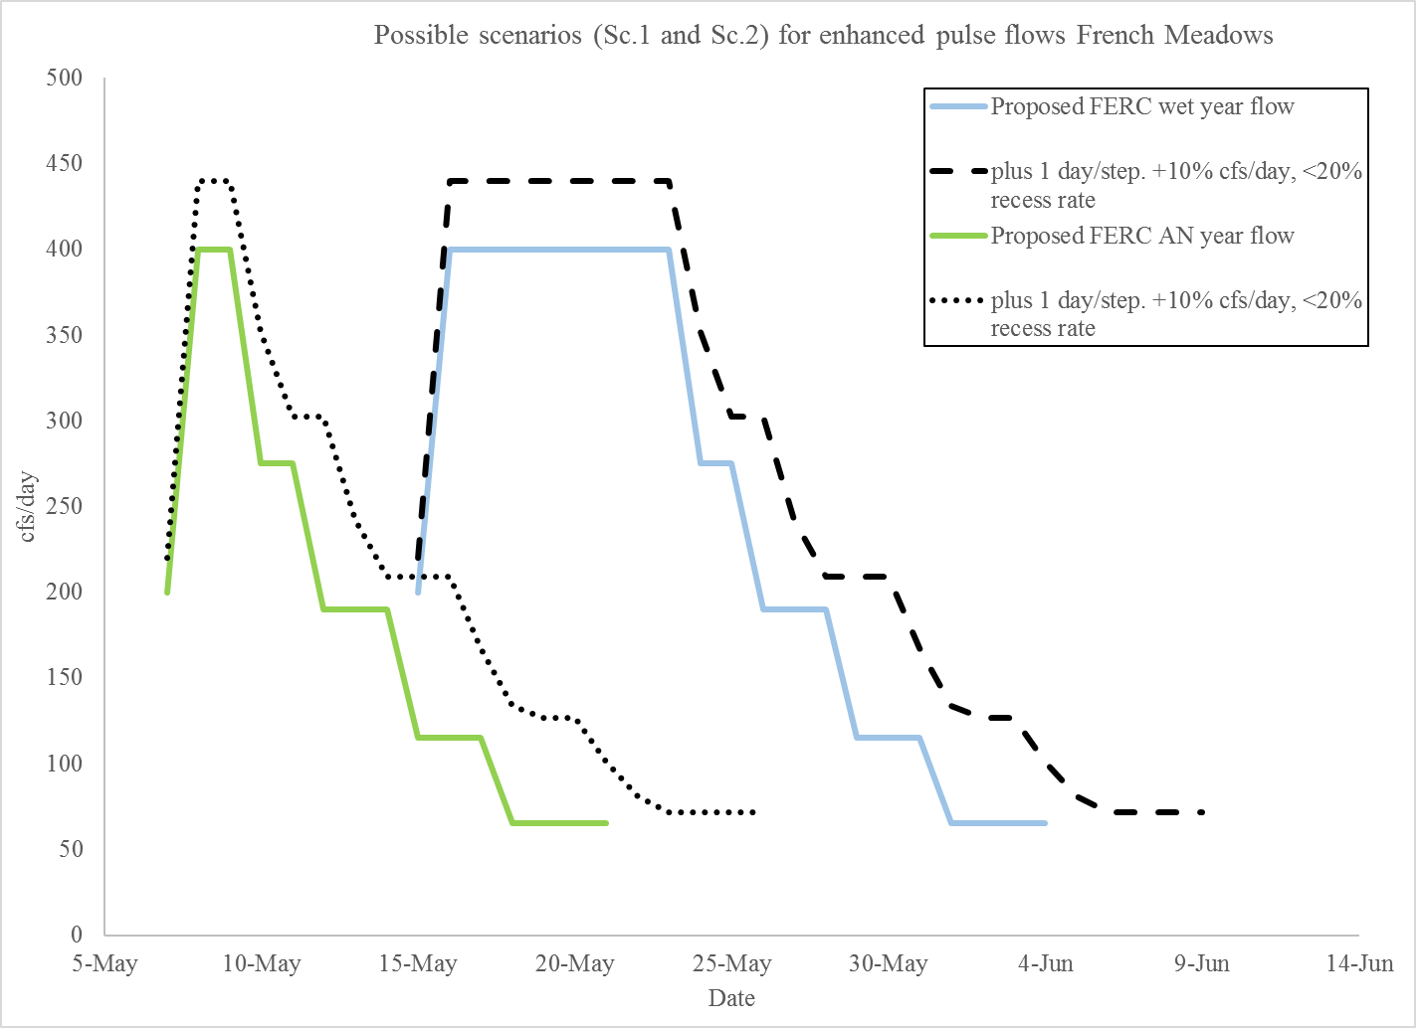

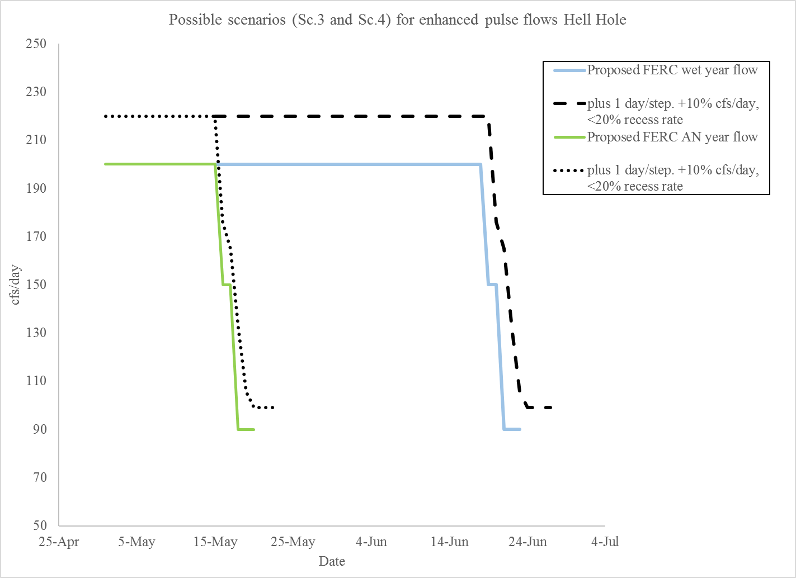

**Spill flows** – In all water years, guarantee the down ramping rate of the spill does not exceed a 20% decrease in flow for each time step. This adds four days to the total spill down ramp duration. For French Meadows Reservoir this equates to and additional 687 cfs and for Hell Hole 1,075 cfs.

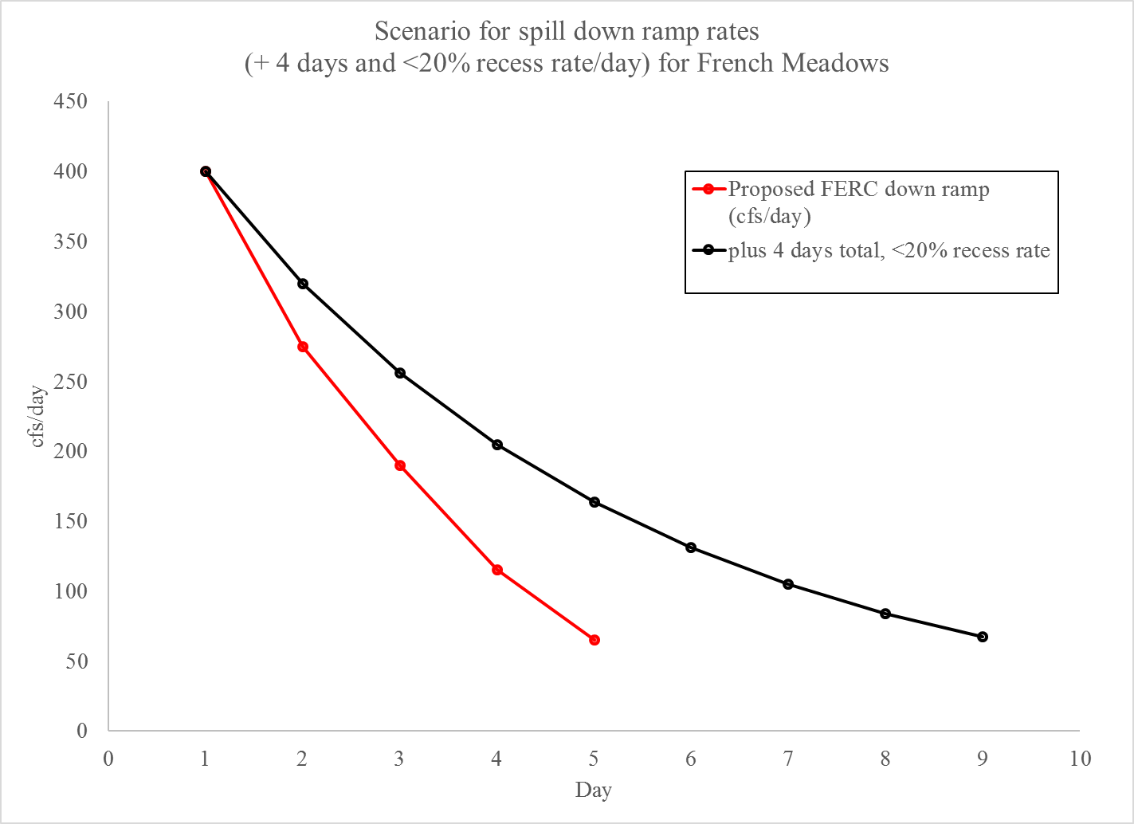

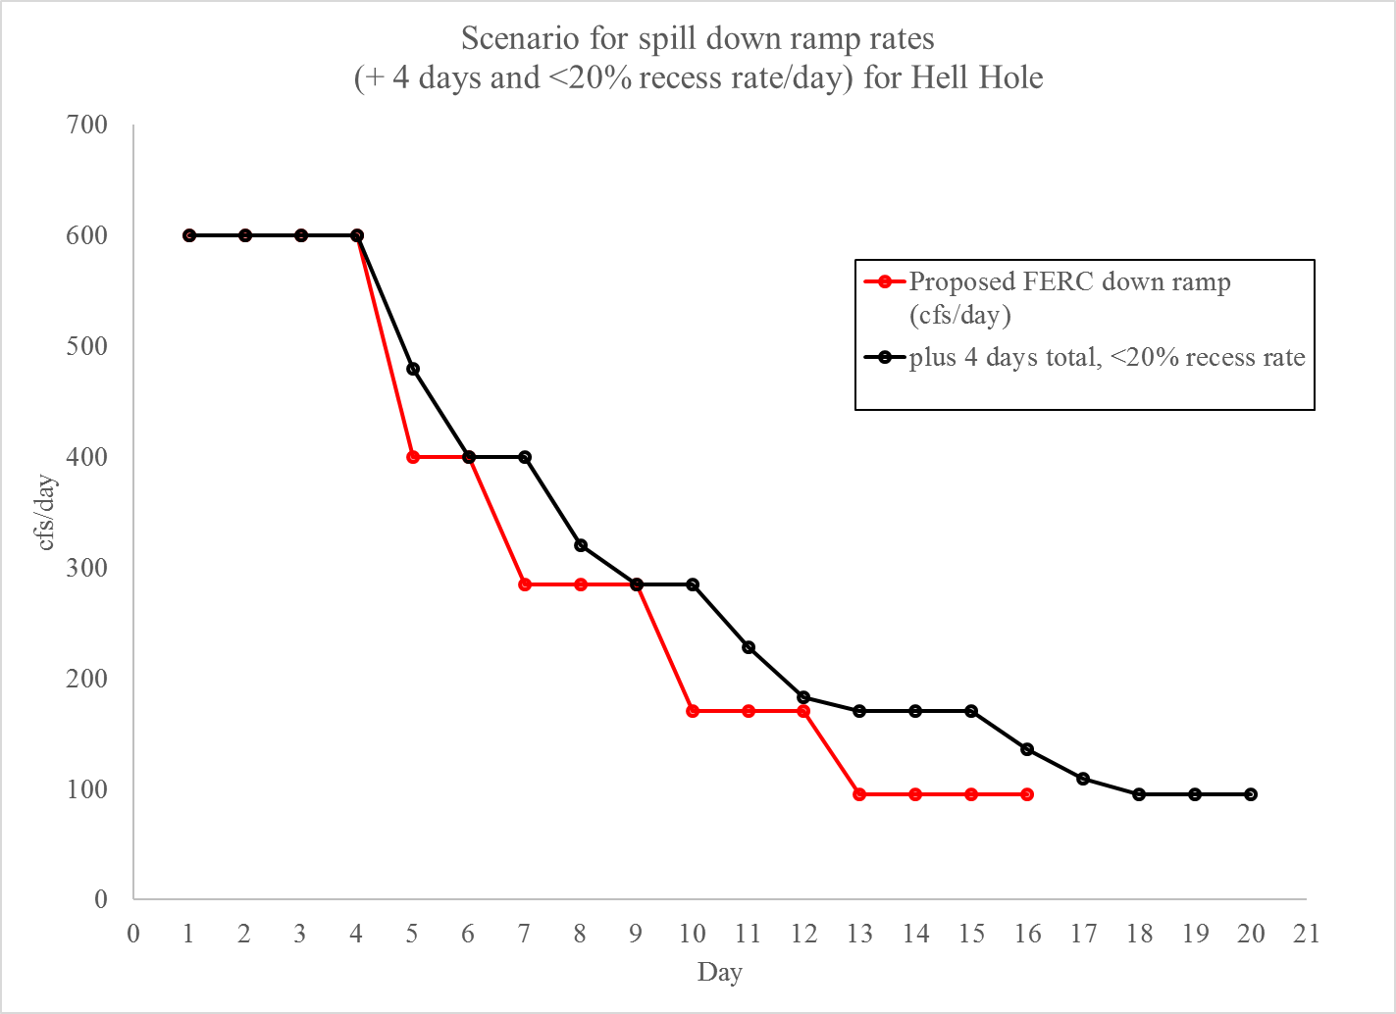

**Pulse flows in additional water year types** – this idea can be described largely qualitatively and doesn’t need to be included in the model, as it’s not currently considered in the proposed license terms. Basically, would additional water from planned forest treatments or wildfire provide enough additional water in a Normal, Below Normal, Critical, Or Critical Dry year for a pulse flow?

**Total flow (cfs) in pulses**

|  |  |  |  |  |
| --- | --- | --- | --- | --- |
| Reservoir | Wet year | Above Normal year | Normal | Below Normal |
| French Meadows | 5,125 | 2,725 | X,xxx | Y,yyy |
| Hell Hole | 4,570 | 3,570 | X,xxx | Y,yyy |

**Sources**

Hayes, M.P., Wheeler, C.A., Lind, A.J., Green, G.A. and Macfarlane, D.C., 2016. Foothill yellow-legged frog conservation assessment in California.

Lind, A.J. 2005. Reintroduction of a declining amphibian: determining an ecologically feasible approach for the foothill yellow-legged frog (Rana boylii) through analysis of decline factors, genetic structure, and habitat associations. Davis, CA: University of California. 169 p. Ph.D. dissertation.

Placer County Water Agency. Draft. Application for New License, Middle Fork American River Project (FERC Project No. 2079), Biological Assessment/Biological Evaluation. Link provided by Marie Davis with PCWA

Podolak and Yarnell, 2015. Adaptive management in Federal Energy Regulatory Commission relicensing: The North Fork Mokelumne and North Fork Feather Rivers, Sierra Nevada, California. in Lassiter, A. ed., 2015. *Sustainable Water: Challenges and Solutions from California*. Univ of California Press.

U.S. Forest Service. Nov. 29, 2012. Forest Service final conditions and recommendations provided unnder 18 CFR § 4.34 (b)(1) In Connection with the Application for Relicensing for the Middle American River Project (FERC No. 2079). Pdf provided by Ben Ransom with PCWA

Yarnell, S.M., Viers, J.H. and Mount, J.F., 2010. Ecology and management of the spring snowmelt recession. *BioScience*, *60*(2), pp.114-127.

Figure x. Foothill yellow legged frog habitat and breeding sites within the Middle Fork American Project. *Maybe remake this map with the area we’re focused on and showing the property ownership and planned forest treatments.*

